**Source Code Repository Document:**

**Introduction:** 1. Repository is a version-controlled storage for your project files, tracking changes with branches and commit over time.

2. It offers a powerful system for managing project history and development workflows.

(OR)

It used to store the project files, code integration at one place and tracking changes history with branches and commit the source code.

3. We have several code repository in the market.

1. SVN

2. GIT Hub

3. Bit Bucket

**GIT HUB:** 1. it is cloud based source code repository server, it is used for storage your project files, tracking changes history, code integration with branches and commit the source code.

2. Maintained by Microsoft, its available trail and commercial plans.

**GIT ENV Setup:**

-> To use GIT hub as repo server then we need to create account.

URL: <https://github.com/>

-> **Please follow below steps for create an account for GIT hub**.

-> Enter the URL in google chrome, <https://github.com/> then we can see the UI design like below.



-> Enter the email id and click on sign up.



-> Then click on continue.

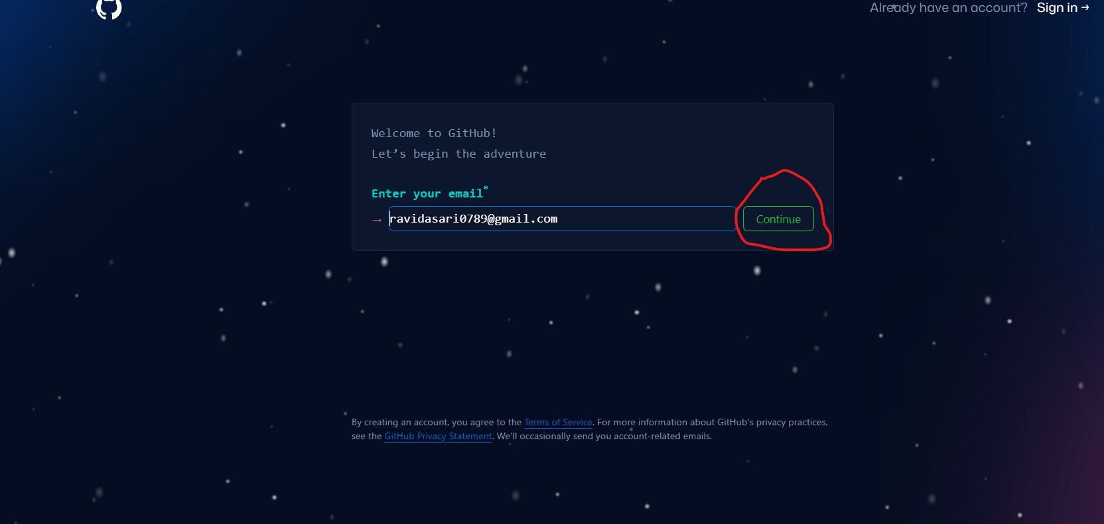

-> Enter the new password and click on continue.

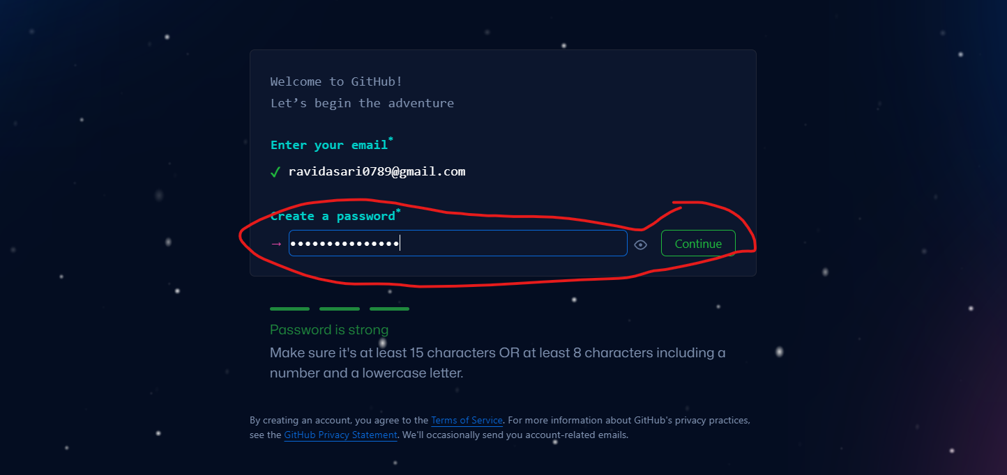

-> enter username and click on continue.

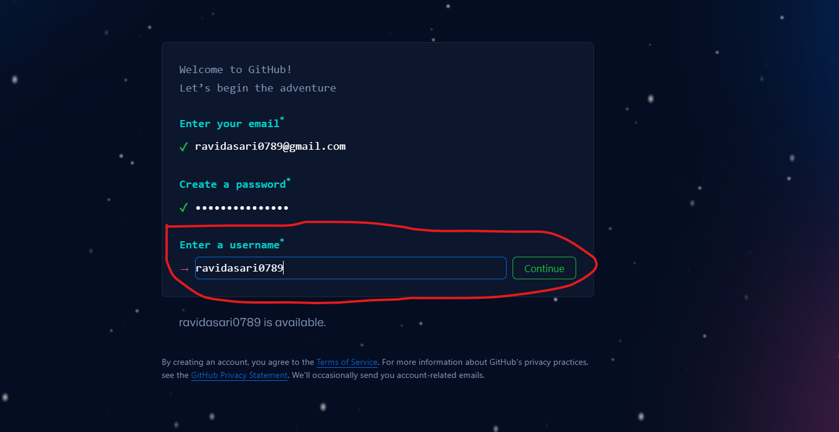

-> Then ✓ in check box and click on continue.

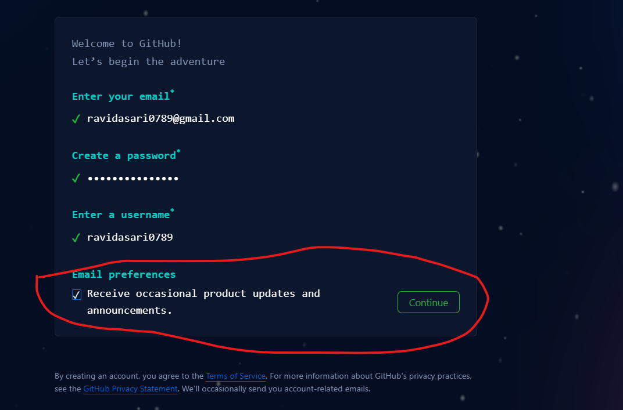

-> verify your account for security and click on submit button.

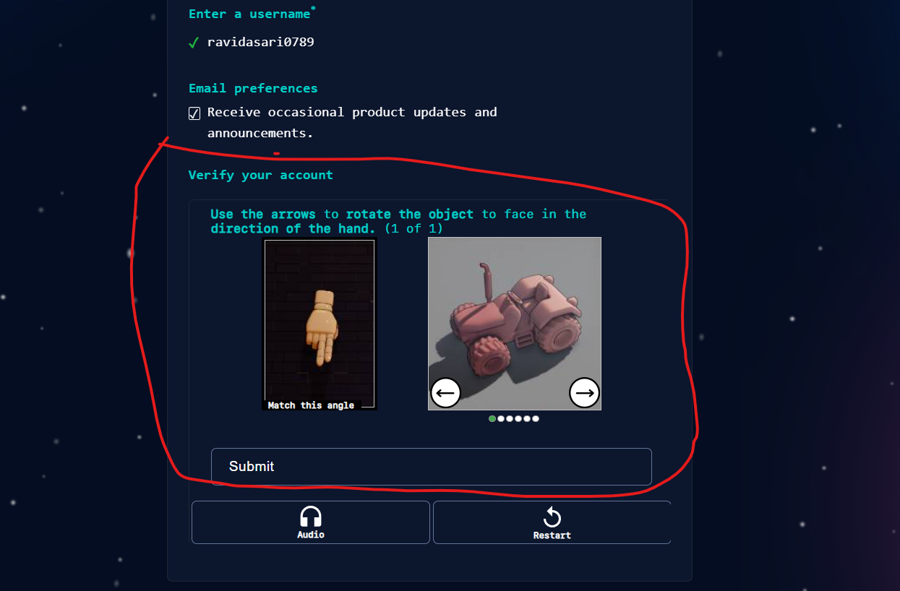

-> Once click on submit then we can see create account, then click on that button also.

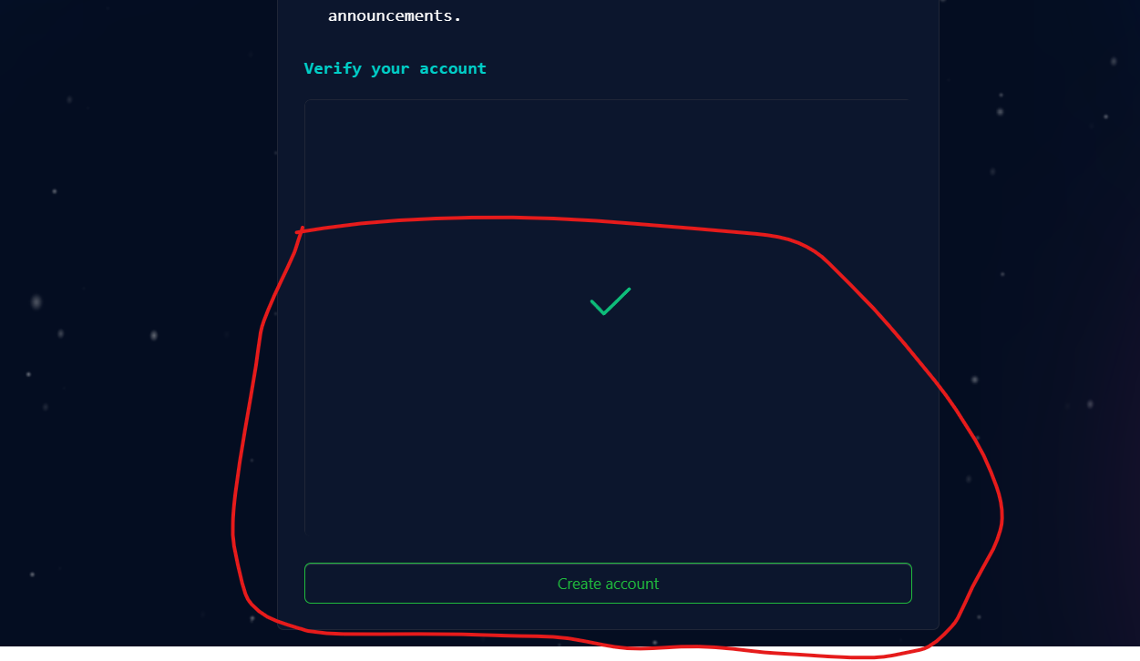

-> Once click on submit button then you can get OTP to your mail id and verify that like below diagram.

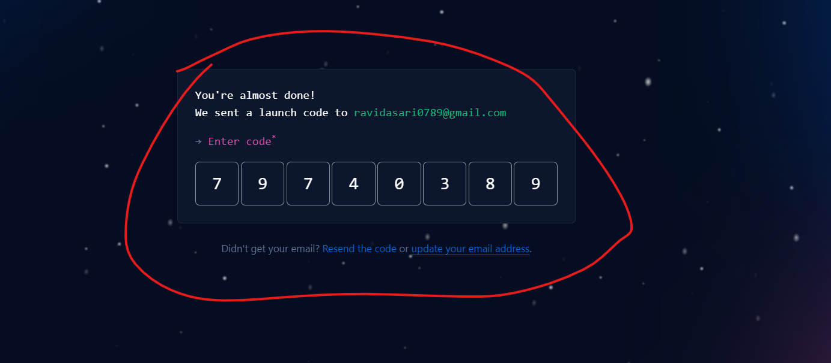

-> Once done verification then you can see welcome GIT Hub and we have questions are there left that, no need fill you have click on skip personalization.

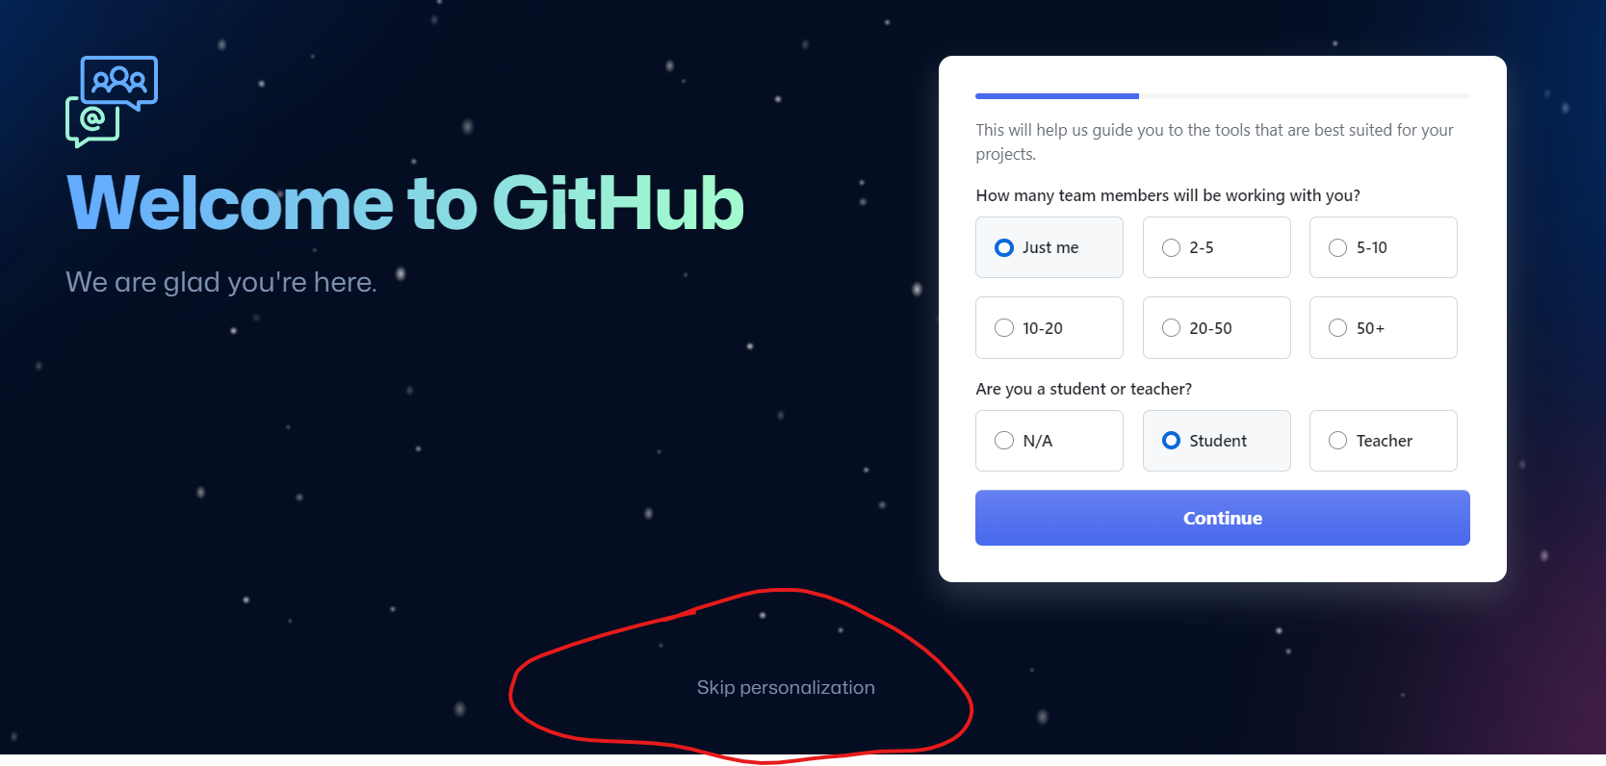

-> Once done skip then you can the dashboard like below diagram.

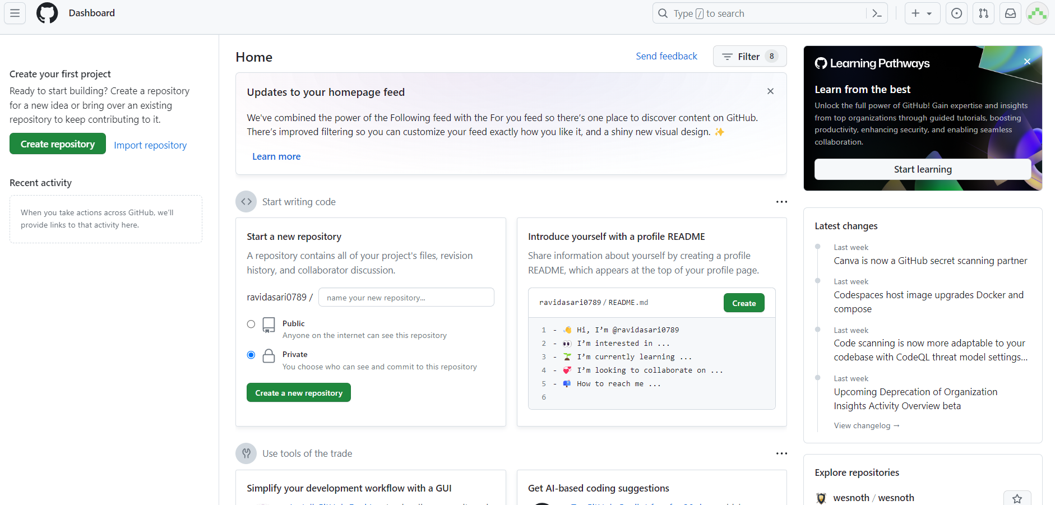

-> **Download and install GIT Client Software.**

-> Click on this URL: <https://git-scm.com/downloads>

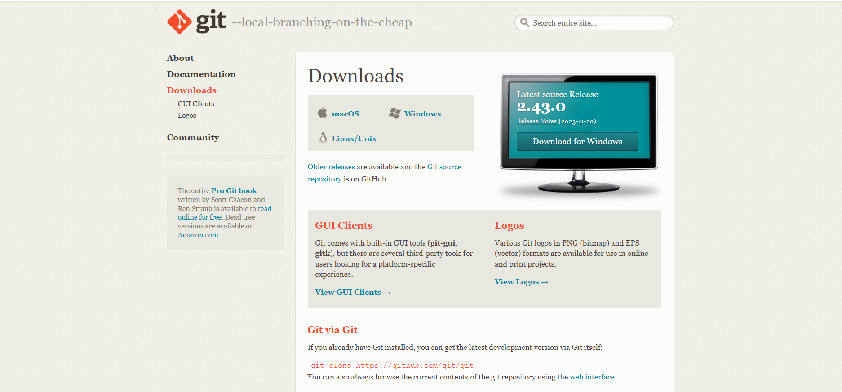

-> double click on GIT client which ever you download and click on yes.

-> Once click on yes then click on next

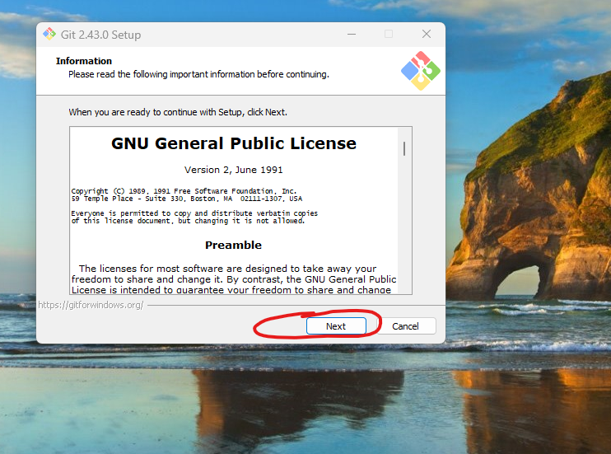

-> Click on next.

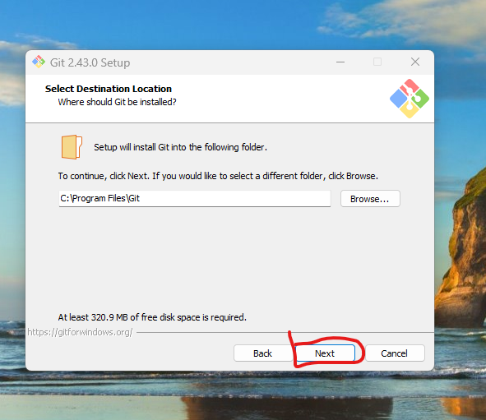

-> Click on next.

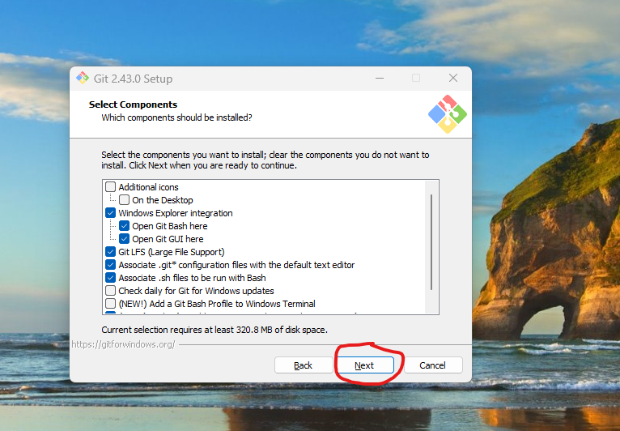

-> Click on next.

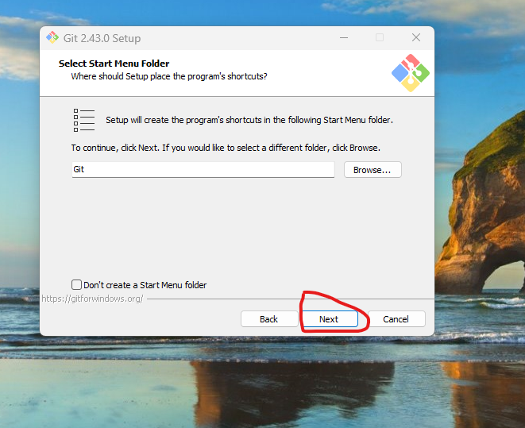

-> Click on next.

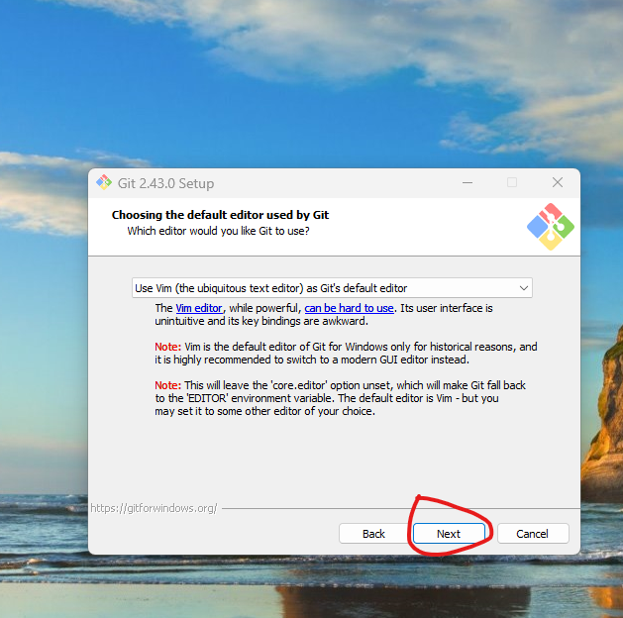

-> Click on next.

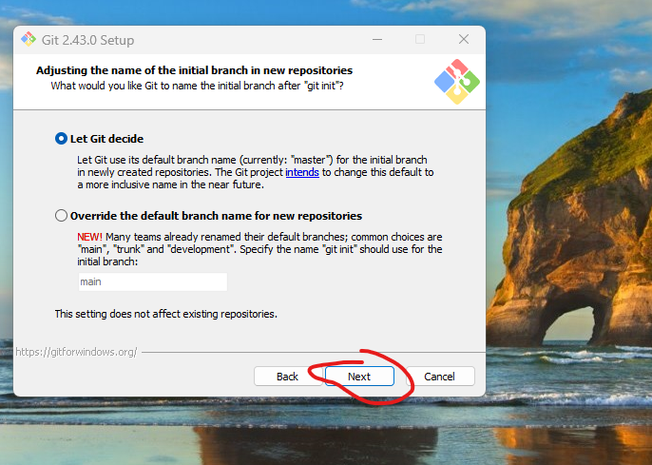

-> Click on next.

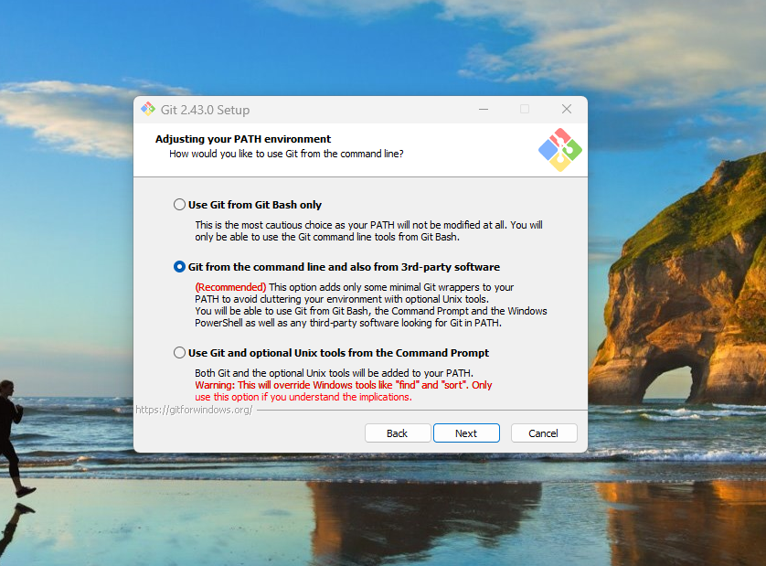

-> Click on next.

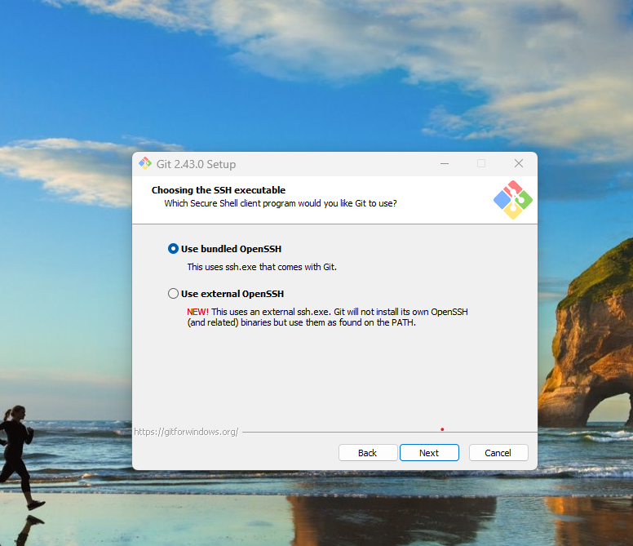

-> Click on next up to install button visible, once visible then you have select the check box and click on install.

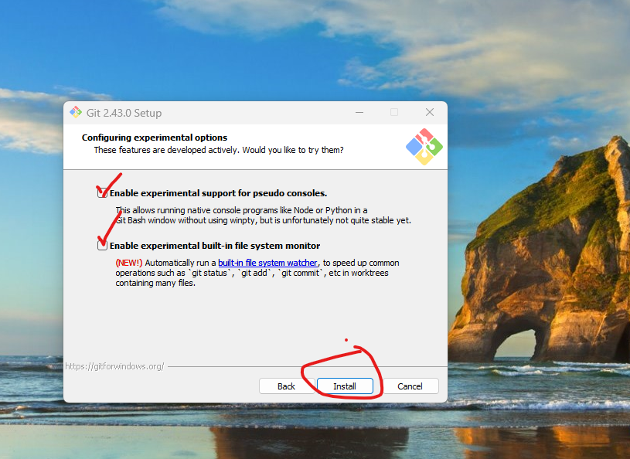

-> Click on finish.

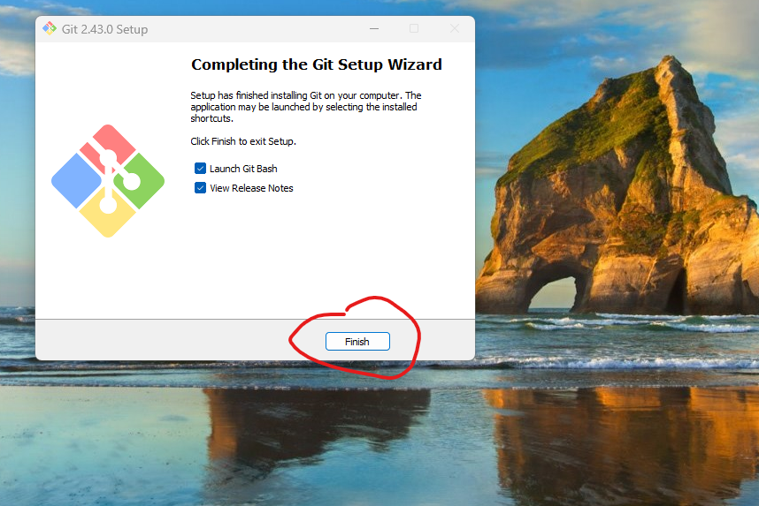

-> Right click and Open Git bash and execute below commands.

git config --global user.name "ravidasari0789"

git config --global user.email [ravidasari0789@gmail.com](mailto:ravidasari0789@gmail.com)

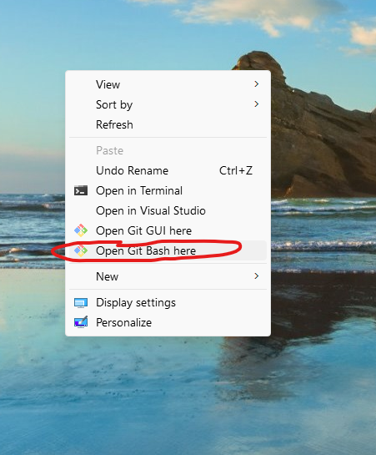

**-> Create New Repository:**

**->** Once login your git hub account then you can see dashboard, in the dashboard you can see create new repository and enter name of repository and select public and click on create repository.

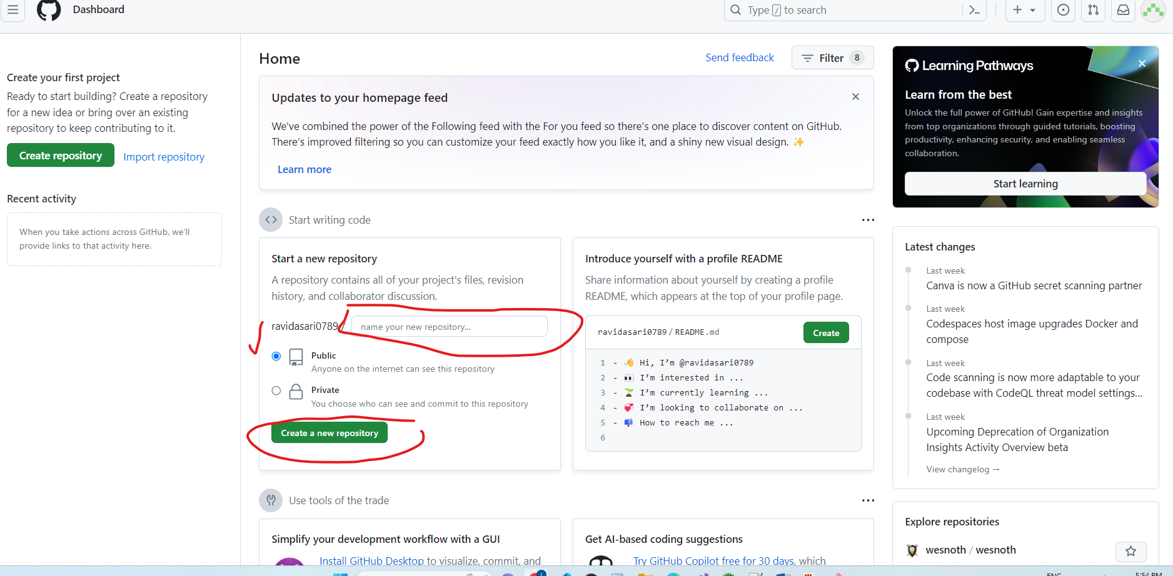

-> Go to project folder, inside folder we have to right click and click on GIT bash here.

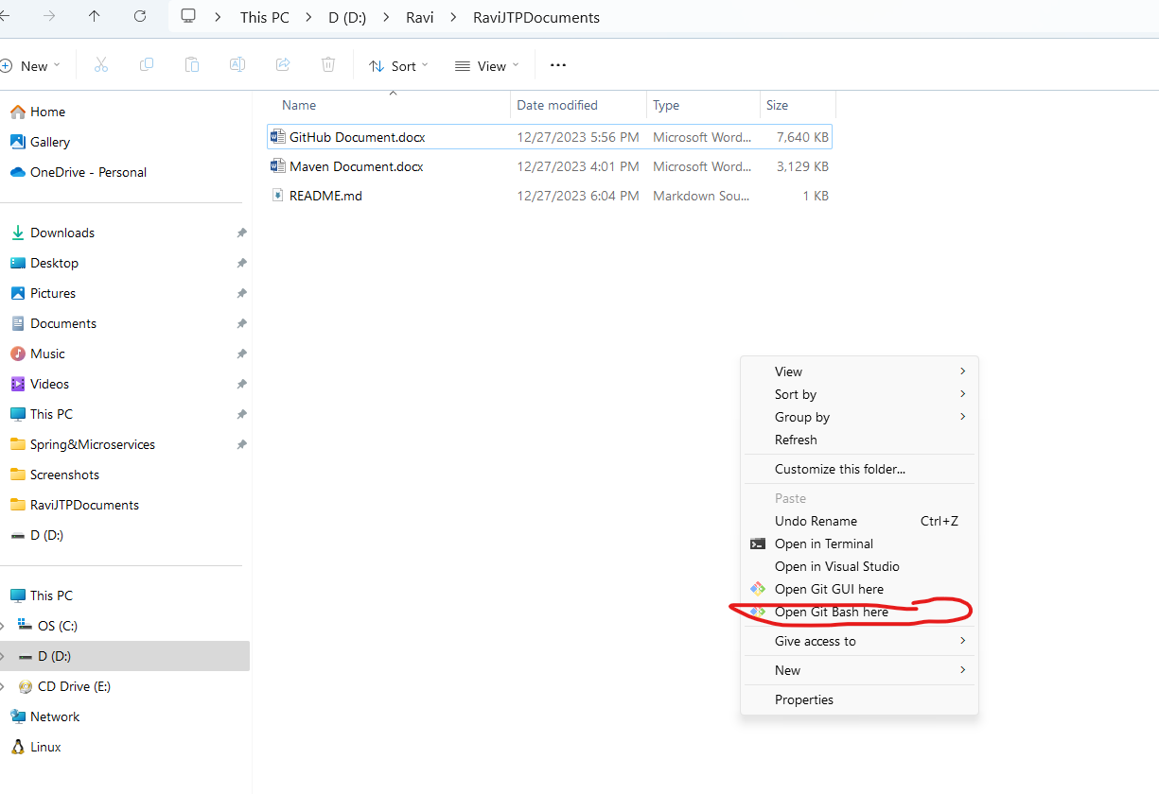

-> Once done, then open GIT hub which ever you created that one copy the commands like below diagram.

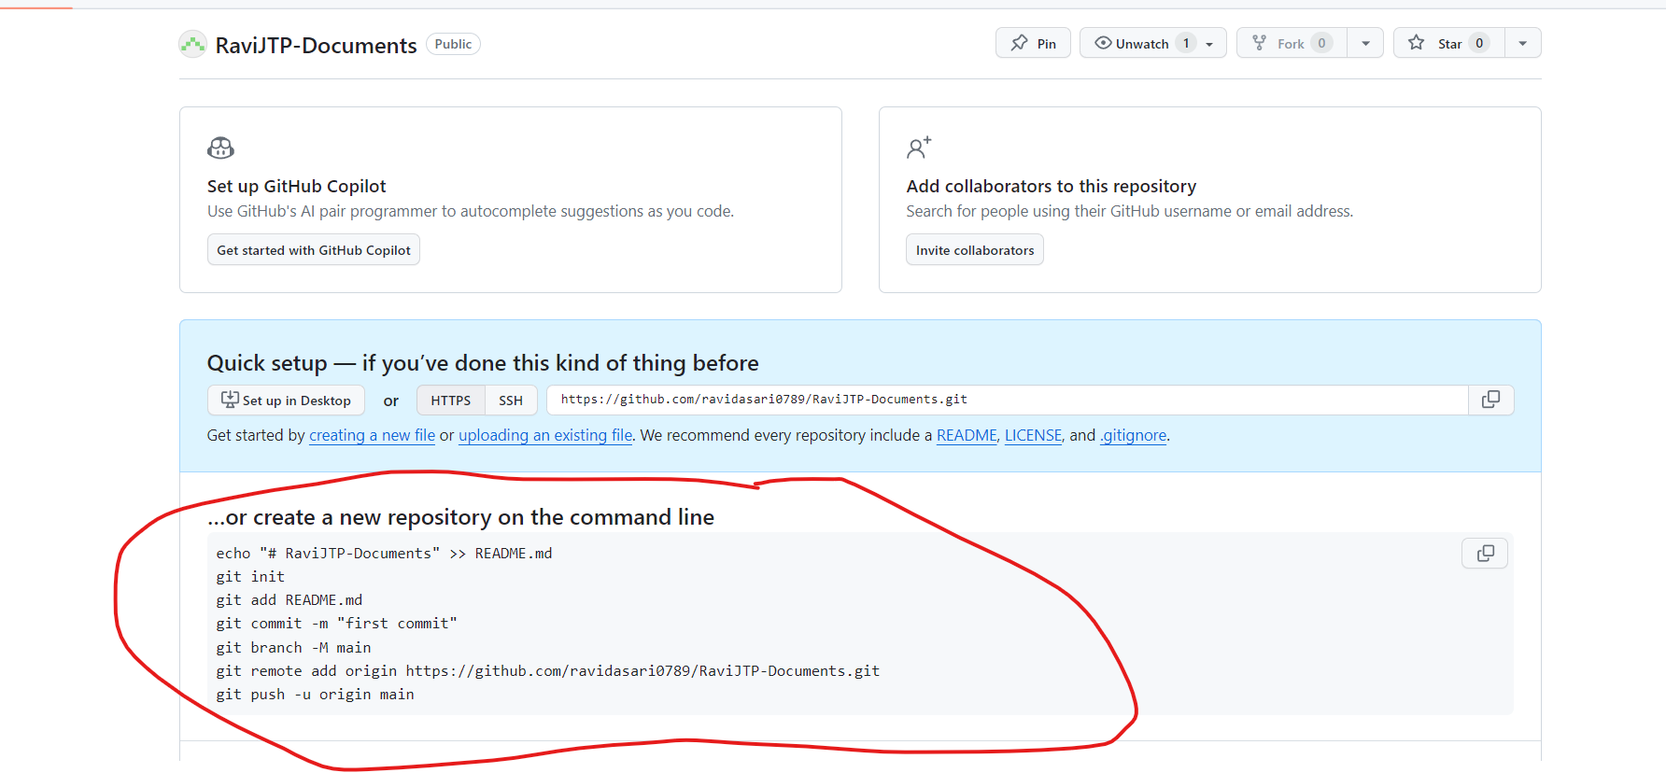

And execute that commands.

-> Once done then you have to add files and committed in local repo and whenever you are going to push files in remote repo at first time then you have to login, so it will display on pop.

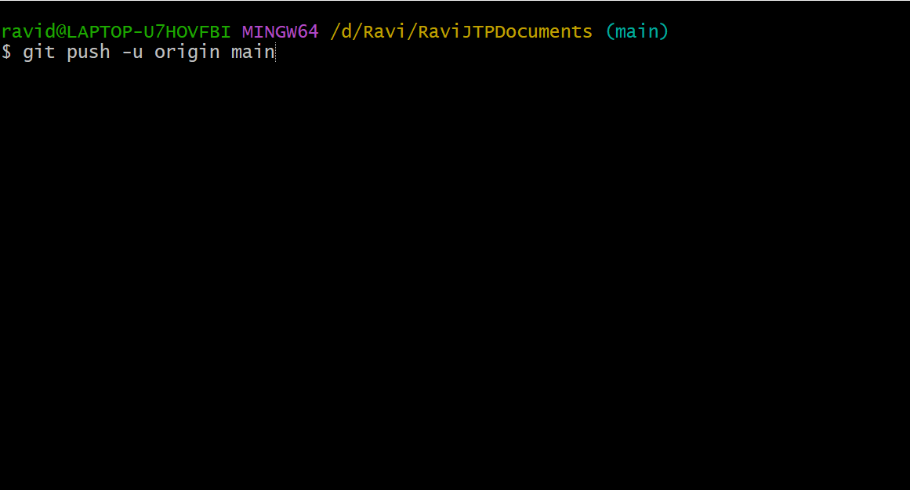

-> Whenever it display pop then you have to select sign in with browser. Once done then successfully stored in remote source code repository.

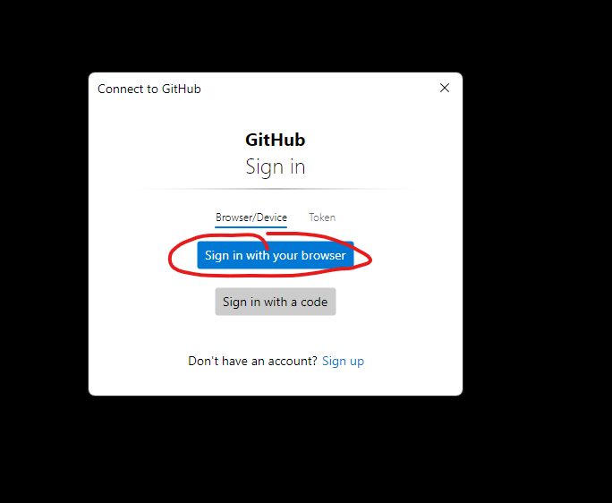

**GIT Architecture:**

1) Git Central Repo

2) Working Tree

3) Staging Area

4) Local Repo

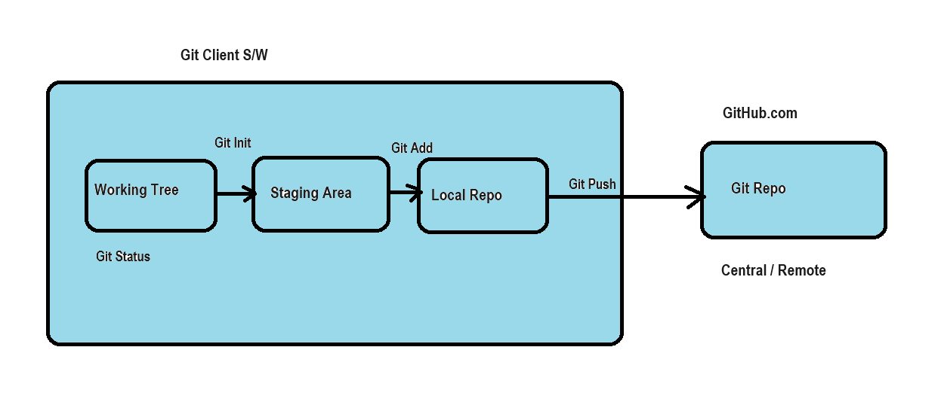

1. **Git Client Software**: If we done changes files or add new files that files if you want to interact with the remote repository which having done changes files or new files then we have to install in your system git client software.
2. Its means Git client is used for interacting with remote repository.
3. **Remote Repository:** it’s a cloud based source code repository used for storing the files in remote repository.

**GitHub Flow:** 1. When we have files or project directory, then we need initialize the **working tree** by using command **GIT INIT**.

2. **Working Tree:** its means which is having project directory or folder for that files when you initialize by using command **GIT INIT** that is called working tree.

3. Once done initialize files or project folder or directory then we need to add files from working tree to staging area then we need to use command **GIT Add**

4. **Staging Area:** its means when we are going to add from working tree to staging area then its eligible to commit the source code files and we can able to store in to remote repo.

5. Once added then we need to commit the source code from staging area to local repo which is have done changes or new files by using command **Git Commit.**

6. **Local Repo:**  which is done commit the source code from staging area to local repo then its eligible to push or store files in remote repository.

7. Once done committed, then we need do push the source code from local repo to remote repo by using command **Git push**

**Git Commands:**

git init: To initialize working tree

git add: To add files to staging area

git status: To check working tree status

git commit: To move changes from staging to local repo

git push: To move changes from local repo to central repo

git log: To check git repo commit history

git clone: To download project from central to local

git pull: Get latest changes from central repo to local

git restore: to discard changes & to un-stage file

git rm: To remove files

Note: When we execute 'git rm' then we have to execute 'commit and push' also to remove file from central repo.

git revert: To revert our changes from central repo

git reset: to undo changes from local repo to staging area.

**Pushing Maven Project to git hub central repo**

1) Create Central repo

2) Op8en git bash from project folder

3) Execute git bash script which is displayed in git central repo

echo "# axis_bank_loans" >> README.md

git init

git add *

git commit -m "first commit"

git branch -M main

git remote add origin <repo-url>

git push -u origin main

git config

git init

git status

git add <filename>

git add --a

git restore

git commit -m <msg>

git reset

git push

git pull

git clone

git log

git rm

git revert

**Git Conflicts:**

-> When we are doing git push, git will check is there any push before our push operation, if there is no push then our push will be success.

-> Before our push, if someone already pushed then our push will be rejected. Here we need to take git pull first then only we can push.

Note: When we do git pull operation, if changes are in the same file and same line then we will get conflicts.

=> We need to resolve git conflicts and we need to push without conflicts.

**Git Branches:**

=> When multiple teams working on same repo it will become difficult to manage source code of all team members

Ex: 20 developers available in our team

5 ppl -> working on enhancements

5 ppl -> working on CR

5 ppl -> working on bug fixing

5 ppl -> working R & D

=> If all developers pushing their changes then it will become very difficult to manage source code.

=> To avoid this problem we will use git branches

=> Git branches will help us in achieving parallel development.

**Branch Names:**

Main (default)

Develop

Feature

Sit

Research

Release

# cloning default branch (i.e. main)

git clone <repo-url>

cd <app-name>

git checkout <branch-name>

# cloning develop branch

git clone -b develop <repo-url>

**What is Pull Request? :**

-> I want to merge changes from one branch to another branch

Ex: develop -----> main

**Git Stash:**

You are watching a movie at home..... (1 hr completed...)

Mom told go out and get milk packet...

Pause movie then bring milk then continue movie.....

Morning 10 am manager assigned task-101...

I am working on it... few changes i have made already...

At 3 pm manager called and told that task-102 is high priority now... first complete task-102 and continue with 101...

Note: In this scenario i can't push 101 task changes because those changes are not completed... I can’t delete those changes because i spent 5 hours to write that code.

-> In this scenario we can go for 'git stash' command.

-> 'git stash' is used to save working tree changes to temp area and makes working tree clean.

-> Once task 102 changes pushed then we can get our task-101 changes back to working tree using 'git stash apply'.

**What is .gitignore file? :**

=> It is used to ignore some files and folders from commit

Ex: class path, .project, .settings and target folder